1 Introduction
In this analysis, we will explore the relationship between color of paper and the percentage of responses given to a questionnaire passed out by the “windshield” method. 15 supermarket parking lots were chosen, and each color was randomly assigned to five lots. The colors used for the questionnaire were blue, green, and orange. The response rates were gathered and shown as percentages in Table 1.
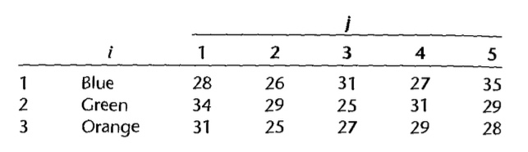
Table 1: Color of Questionnaire and Response Percentage
- This study is a single-factor experimental study. We are investigating how different levels (colors) of this single factor affect the response rates to the questionnaire.
- The explanatory factor is the color of the cards placed on the person’s windshield. This factor has three levels: blue, green, and orange. The response variable is the percentage of responses for each color.
- The experimental units being studied are the 15 parking lots chosen which receive one of the three colors of paper.

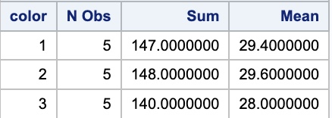
Table 2: Mean Number of Responses by Percentage
2 Descriptive Statistics: A Higher-Level View
The number of observations, total sum, and means for each level of the observational factor can be found in Table 2. In this table, 1 will represent blue, 2 will represent green, and 3 will represent orange. From an initial analysis using these basic descriptive statistics, the means appear to be very similar which could indicate that there may not be a large difference in response rates based on paper color. However, it is important to note that color 2 (Green) has the highest response rate at 29.6 and color 3 (Orange) has the lowest mean response rate at 28.0. This is consistent with the analysis that green had the most responses with 148 while orange had the least number of responses with 140. We understand that these results alone are not enough to determine if questionnaire color has a correlation with response percentage. Thus, we will first turn to a single-factor ANOVA model.

3 Single Factor ANOVA Model: Cell Means Model
The ANOVA Cell Means Model can be stated as follows:
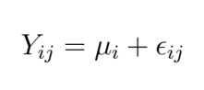 (1)
In this model, Y_{ij} is observed response rate (percent) for jth parking lot assigned to the ith color. μ_{i} are parameters where the factor level mean will be used. In this study, it will represent the mean response rate for color i in which each treatment will have its own mean. ε_{ij} is the error term for the jth parking lot at the ith color. The mean percentage of responses for each factor level was compared using the following hypothesis test and statistic. It is important to note that all tests were run with α = 0.05.
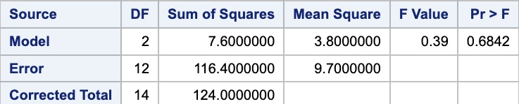
Table 3: Data for F Test for ANOVA Model
Test: H₀ : μ₁ = μ₂ = μ₃ = 0 vs. H₁ : not all μ_{I} are equal
Test Statistic: F = $\frac{MSTR}{MSE}$
All data found for this analysis can be found in Table 3. We can use the F distribution table to determine that F (0.95; 2, 12) = 2.81. To determine if our F-value is significant, we compare the two values. Since F = 0.39 in our table, F < F (0.95; 2, 12). Therefore, we can conclude that we should fail to reject H₀. In conclusion, by analysis of the F-value, there is no significant difference between the mean response rates for different paper colors. The slight differences observed in sample means are likely due to random variation rather than a true effect of color.
We can use our p-value to solidify our findings. In our table, the p-value is 0.6842. Since this p-value is greater than α = 0.05, we would fail to reject the null hypothesis. This means that there is no significant relationship between color and response rate. In other words, color has no statistically significant effect on response rate.
Figure 1 can help to cement our findings in Section 1 and 2. Visually, we can see that the means do not have much variation between colors, along with all other measures of central tendency such as the first quartile of colors 1 and 2 along with the 3rd quartile of colors 1 and 3. With this being confirmed, we will need another layer of analysis.
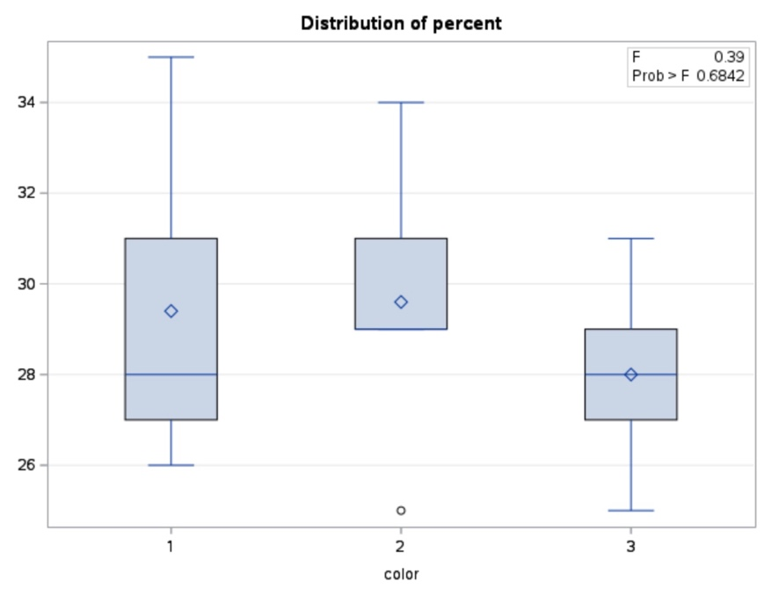
Figure 1: Box-and-Whisker Plot by Questionnaire Color

4 Factor Effects Model with Unweighted Mean and Regression Model
Next, we will analyze the nature of factor level means when slight differences exist, but not enough to be significant. To achieve this, we will transform the Cell Means model from equation (1) into an equivalent representation known as the factor effects model, as shown below:
Y_{ij} = μ. + τ_{i} + ε_{ij} (2)
In this model, Y_{ij} is the response variable and represents the percentage of questionnaires responded to for the jth lot assigned to the ith color. μ. is the overall mean response rate across all groups, in other words, it will be the constant component common to all observations. τ_{i} is the effect of the ith color, which is the deviation of the color’s mean from the overall mean. ε_{ij} is the random error term.
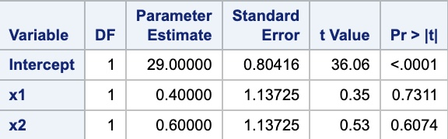
Table 4: Regression Data from Factor Means Model
The factor effects model with unweighted mean can be used to develops a linear regression model. To create a model studying the effects of 3 factor levels, we used dummy variables x1 to represent blue and x2 to represent green. Orange will be represented by a -1 for each dummy variable. The intercept represents the overall mean response rate, in other words, it is the grand mean of all three colors.
We can look at the regression equation as follows:
Y = β₀ + β₁x₁ + β₂x₂ + ε (3)
In this model, β₀ represents the unweighted mean of all three groups, β₁ represents the difference between blue and orange, β₂ represents the difference between green and orange, and ε represents the standard error. The mean for blue can be seen as β₀ + β₁. The mean for green can be seen as β₀ + β₂, and the mean for orange can be seen as β₀ - β₁ - β₂.
Next, we examine the regression model, with the corresponding data represented in Table 4. Given that our significance level is α = 0.05, we will first re-evaluate the null and alternative hypothesis established in the Cell Means model. The first thing that we can note is that our p-value for the t-test on our intercept is < .0001 < 0.05. This means that we would reject the null hypothesis and conclude that the response rate is not equal to 1. In this case, the intercept is 29.000 so the response percentage is 29% which is not equal to 1. We have separate tests for the null hypothesis on our x terms. For x1, we can notice that our p-value is 0.7311 which is significantly higher than 0.05. This would mean that we would fail to reject the null hypothesis and further conclude that blue paper had no impact on response rates. Next, we can look at the p-value of x2. We can see that the p-value for x2 is equal to 0.6074, which again is significantly larger than 0.05. Again, we would fail to reject the null hypothesis and conclude that green has no statistical significance on response rates. We can use the values in Table 4 to conclude that there are not significant differences in response rates based on color, and this can be further proved by looking at Figure 1. The box-and-whiskers plot shows comparable distributions of responses throughout all colors. We can use the table to create our regression model:
Ý = 29.0000 + 0.4000x₁ + 0.6000x₂ (4)
This model has an adjusted R² value of 0.0613 which further helps us determine that paper color has no real significance on response rate. These findings align with our findings for the ANOVA model; however, further investigation is needed.
5 Tukey Multiple Comparison Procedure
We have decided to use the Tukey Multiple Comparison Procedure because it helps us evaluate whether there are significant differences in response rates between our three colors. This test is better suited to help us determine significant colors. For the Tukey Comparison Procedure, our test becomes:
Test: H₀ : µ_{A} = µ_{B} vs. H₁ : µ_{A} - µ_{B} ≠ 0
Our results from the Tukey procedure can be found in Table 5. As we can see in the table, the value 0 is obtained in in every difference of means of questionnaire colors. This can be seen in the “Simultaneous 90% Confidence Limits” section of the table. For every color comparison, 0 is within the confidence interval when α = 0.10. Thus, we can fail to reject the null hypothesis and conclude that no color significantly increases or decreases response rates compared to others.
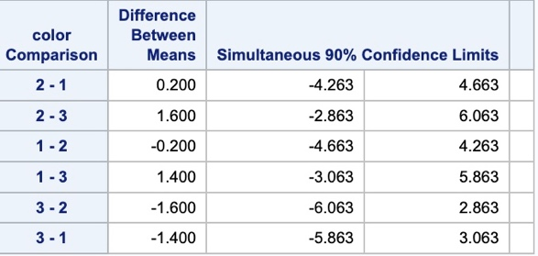
Table 5: Results from Tukey Multiple Comparison Procedure
6 Scheffé’s Multiple Comparison Procedure
Next, we will look at Scheffé Multiple Comparison Procedure. Like the Tukey procedure, this procedure is used to examine differences in response rates across the three questionnaire colors; however, this procedure is more general and can be used for comparing any combination of group means. This means that this test can be used to explore a broader range of comparisons beyond direct mean differences. The Scheffé test is as follows:
L = ∑ c_{i}µ_{i} where ∑ c_{i} = 0
H₀ : L = 0
H₁ : L ≠ 0
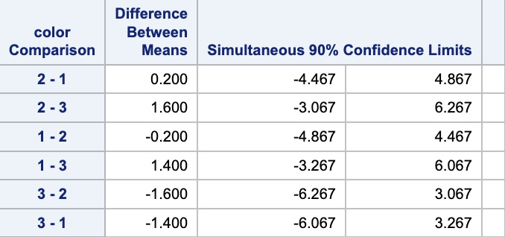
Table 6: Results from Scheffé Multiple Comparison Procedure
Our results from the Scheffé procedure can be found on Table 6. We can see on the table that the value 0 is obtained in every comparison (can be seen in the “Simultaneous 90% Confidence Limits” section.) It is important to note that we used α = 0.10 for this analysis to increase the chances of finding significance. Again, we can see that confidence interval for every comparison includes 0, which means that the difference is not statistically significant. Thus, based on Scheffé multiple comparison procedure, we would fail to reject the null hypothesis at the 90% confidence level and further determine that the color of the questionnaire paper has no statistical significance in response percentage. This is cohesive with our findings in the Tukey comparison procedure; however, we must run one more comparison procedure to be sure.
7 Bonferroni Multiple Comparison Procedure
Finally, we will look at Bonferroni Multiple Comparison Procedure. This procedure will be included because unlike the Tukey and Scheffé models, this procedure is particularly useful when conducting a smaller number of comparisons. We will use this procedure to compare the mean response percentages across different paper colors. The test statistics are as followed:
Test: H₀ : L = 0 vs. H₁ : L ≠ 0
Test Statistic: t* = $\frac{Lˆ}{S(Lˆ)}$
If |t*| ≤ t (1 - α/2g; n_{T} - r), we conclude H₀ ; otherwise, H₁ is concluded.
Our results from the Bonferroni procedure can be found in Table 7. Again, we can see in the table that the confidence interval for every comparison includes 0. This can be seen in the “Simultaneous 75% Confidence Limits” section of Table 7. It is also important to note that we used an alpha value of α = 0.25. This alpha level is relatively high and means that the test is more lenient in detecting significant differences compared to lower alpha values. Since none of the comparisons appear to have confidence intervals that include 0, we can fail to reject the null hypothesis and conclude that there is no significant difference between color at the 75% confidence level. Since all confidence intervals contain 0, none of the color groups show a statistically significant difference in response rates under the Bonferroni-adjusted test at α = 0.25.
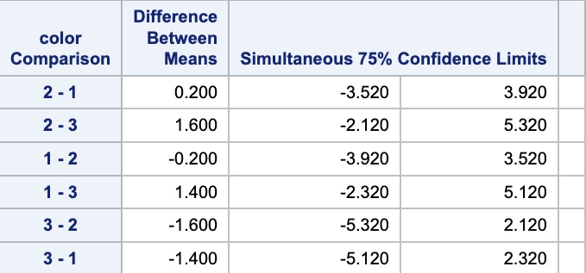
Table 7: Results from Bonferroni Multiple Comparison Procedure
8 Conclusion
This analysis examined the effect of paper color on questionnaire response rates in supermarket parking lots by using blue, green, and orange paper. To assess potential significance in paper color, we implemented a single-factor ANOVA model (cell means model), a factor effects model with an unweighted mean, and a regression model, followed by multiple comparison procedures, including Tukey’s HSD, Scheffé’s method, and the Bonferroni procedure.
The ANOVA results provided an initial assessment of whether differences existed among the response rates for different paper colors. The factor effects model with an unweighted mean and the regression model further examined the relationship between paper color and response rates and confirmed the findings from the ANOVA model. Across all models, results indicated that there is no true relationship between questionnaire colors and response rates.
Furthermore, Tukey’s test, Scheffé’s method, and Bonferroni’s procedure were applied to further validate the findings. Tukey’s test showed no significant differences between colors at the 0.1 level, while Scheffé method further confirmed this analysis. A more lenient 0.25 alpha level was applied for Bonferroni’s procedure and still found no significant differences. This confirmed our prior analysis that paper color does not impact response rates.
In conclusion, the combined results of all models implemented confirmed that paper color has no significant impact on response rates. Future research would need to be implemented to make these conclusions more global such as, wording or time of day.

